

**Destroy Duck December**

**Chayanin Kongsareekul, Kamamnun Maneesri, Thitrin Sastarasadhit**

**Chulalongkorn University**

28/08/2024

Destroy Duck December

Chulalongkorn University

CU

1

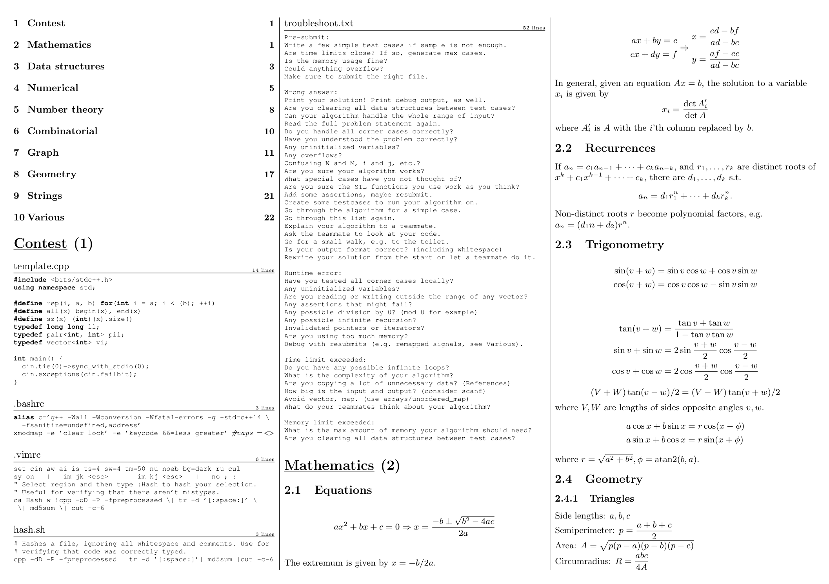

CU

2

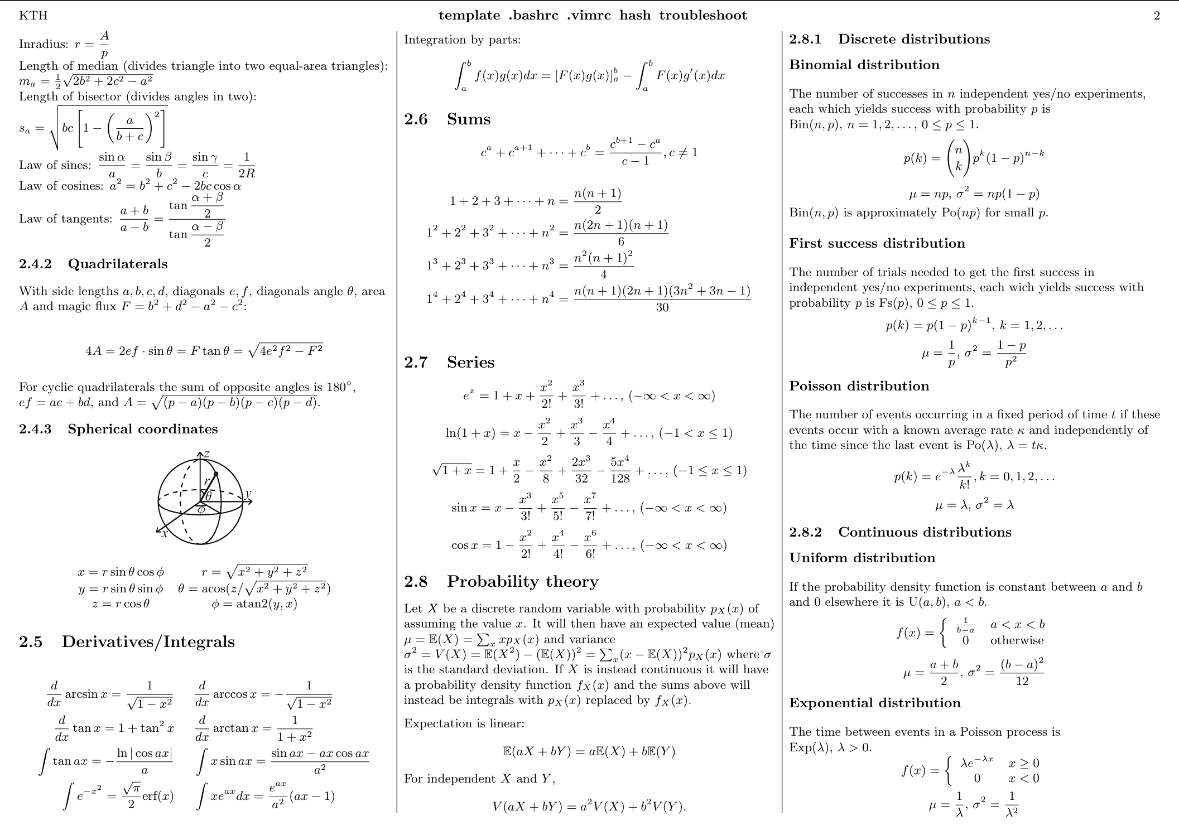

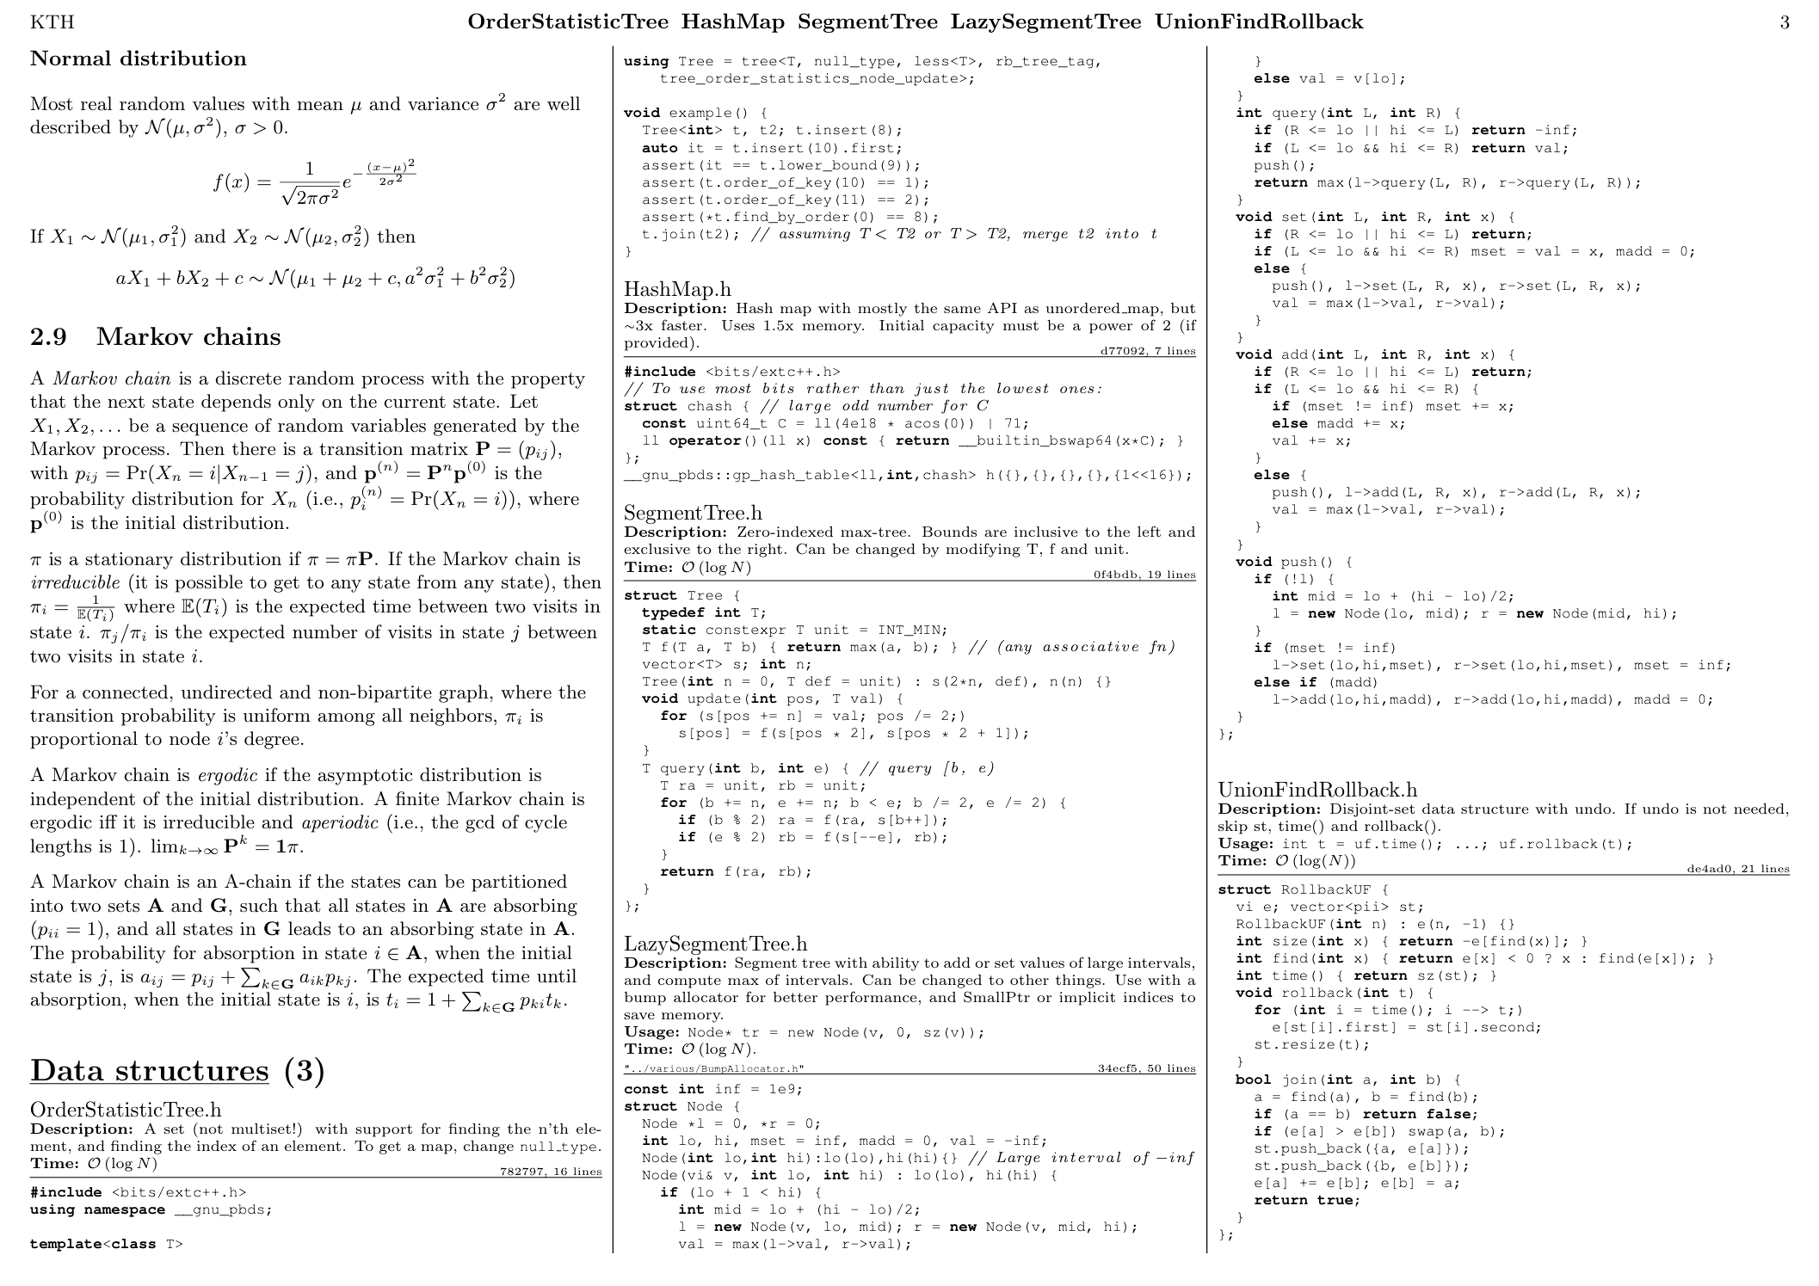

CU

3

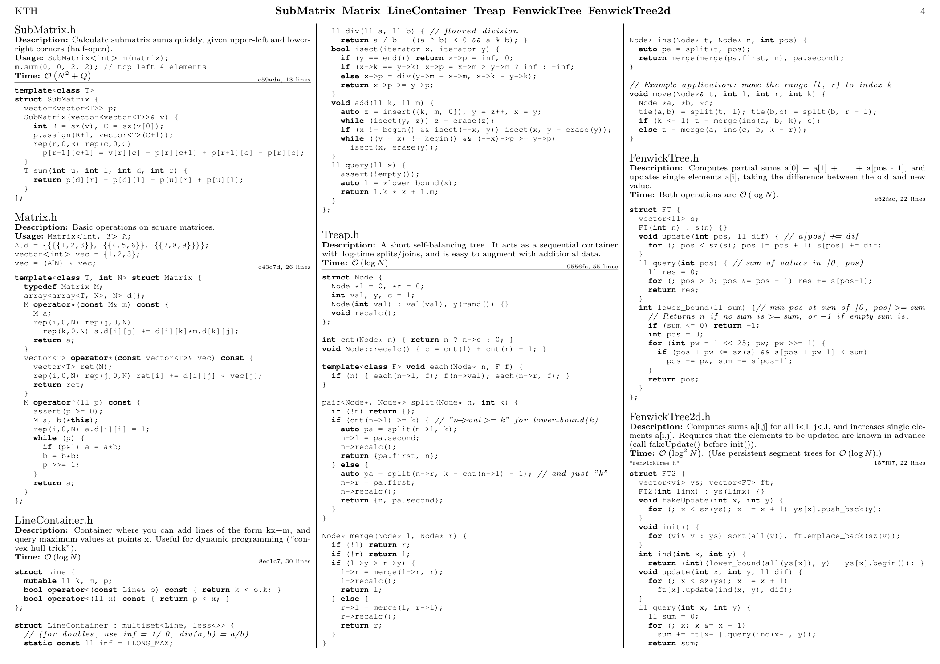

CU

4

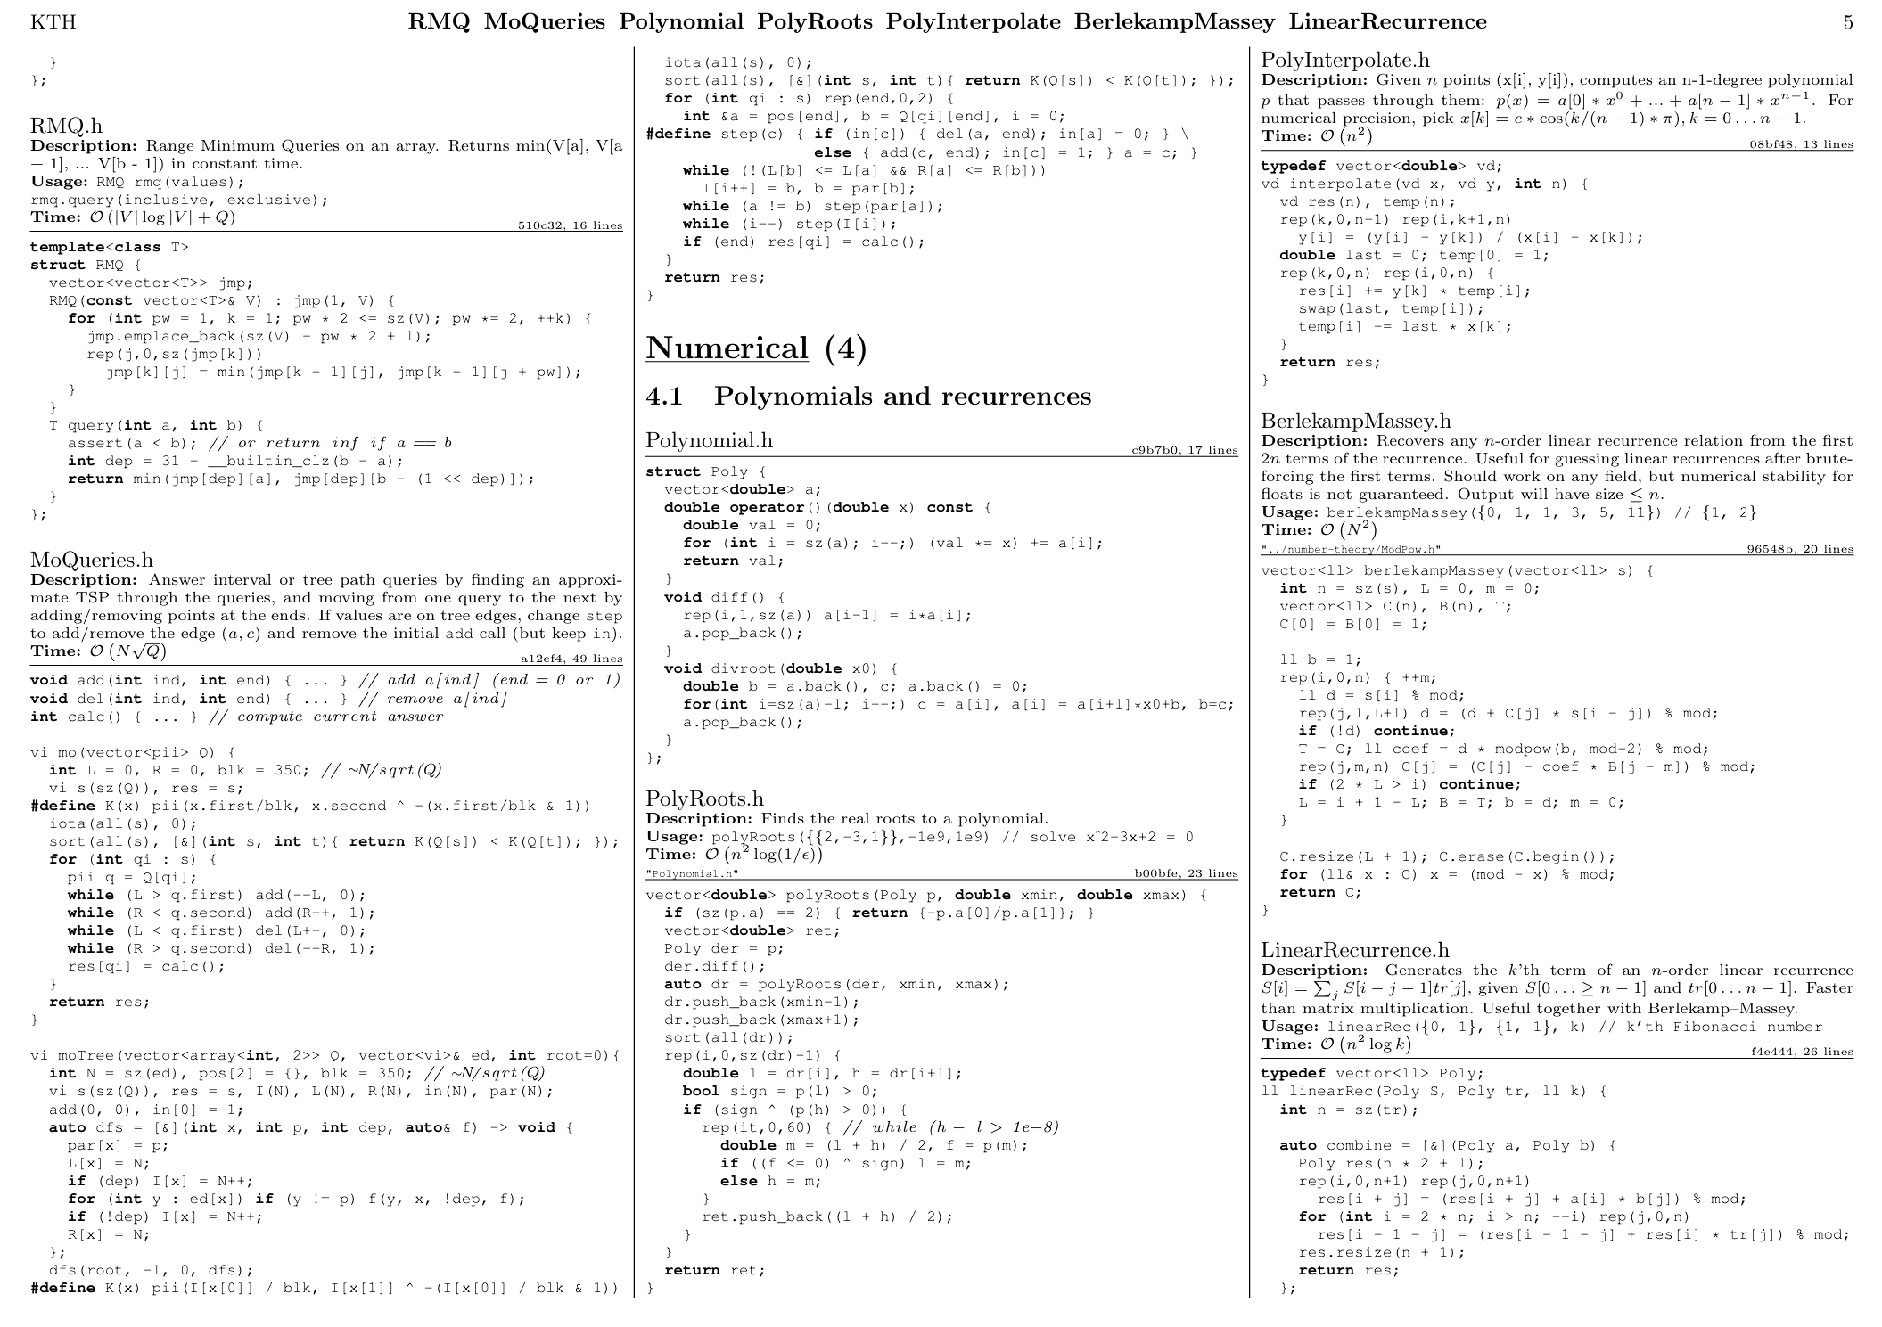

CU

5

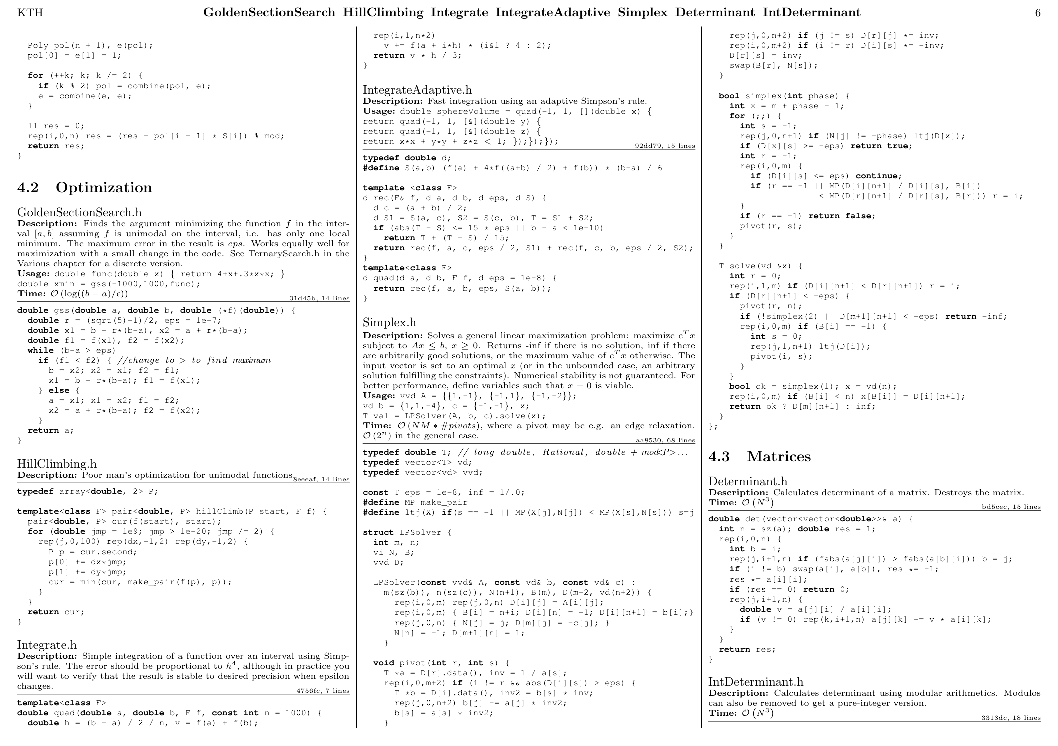

CU

6

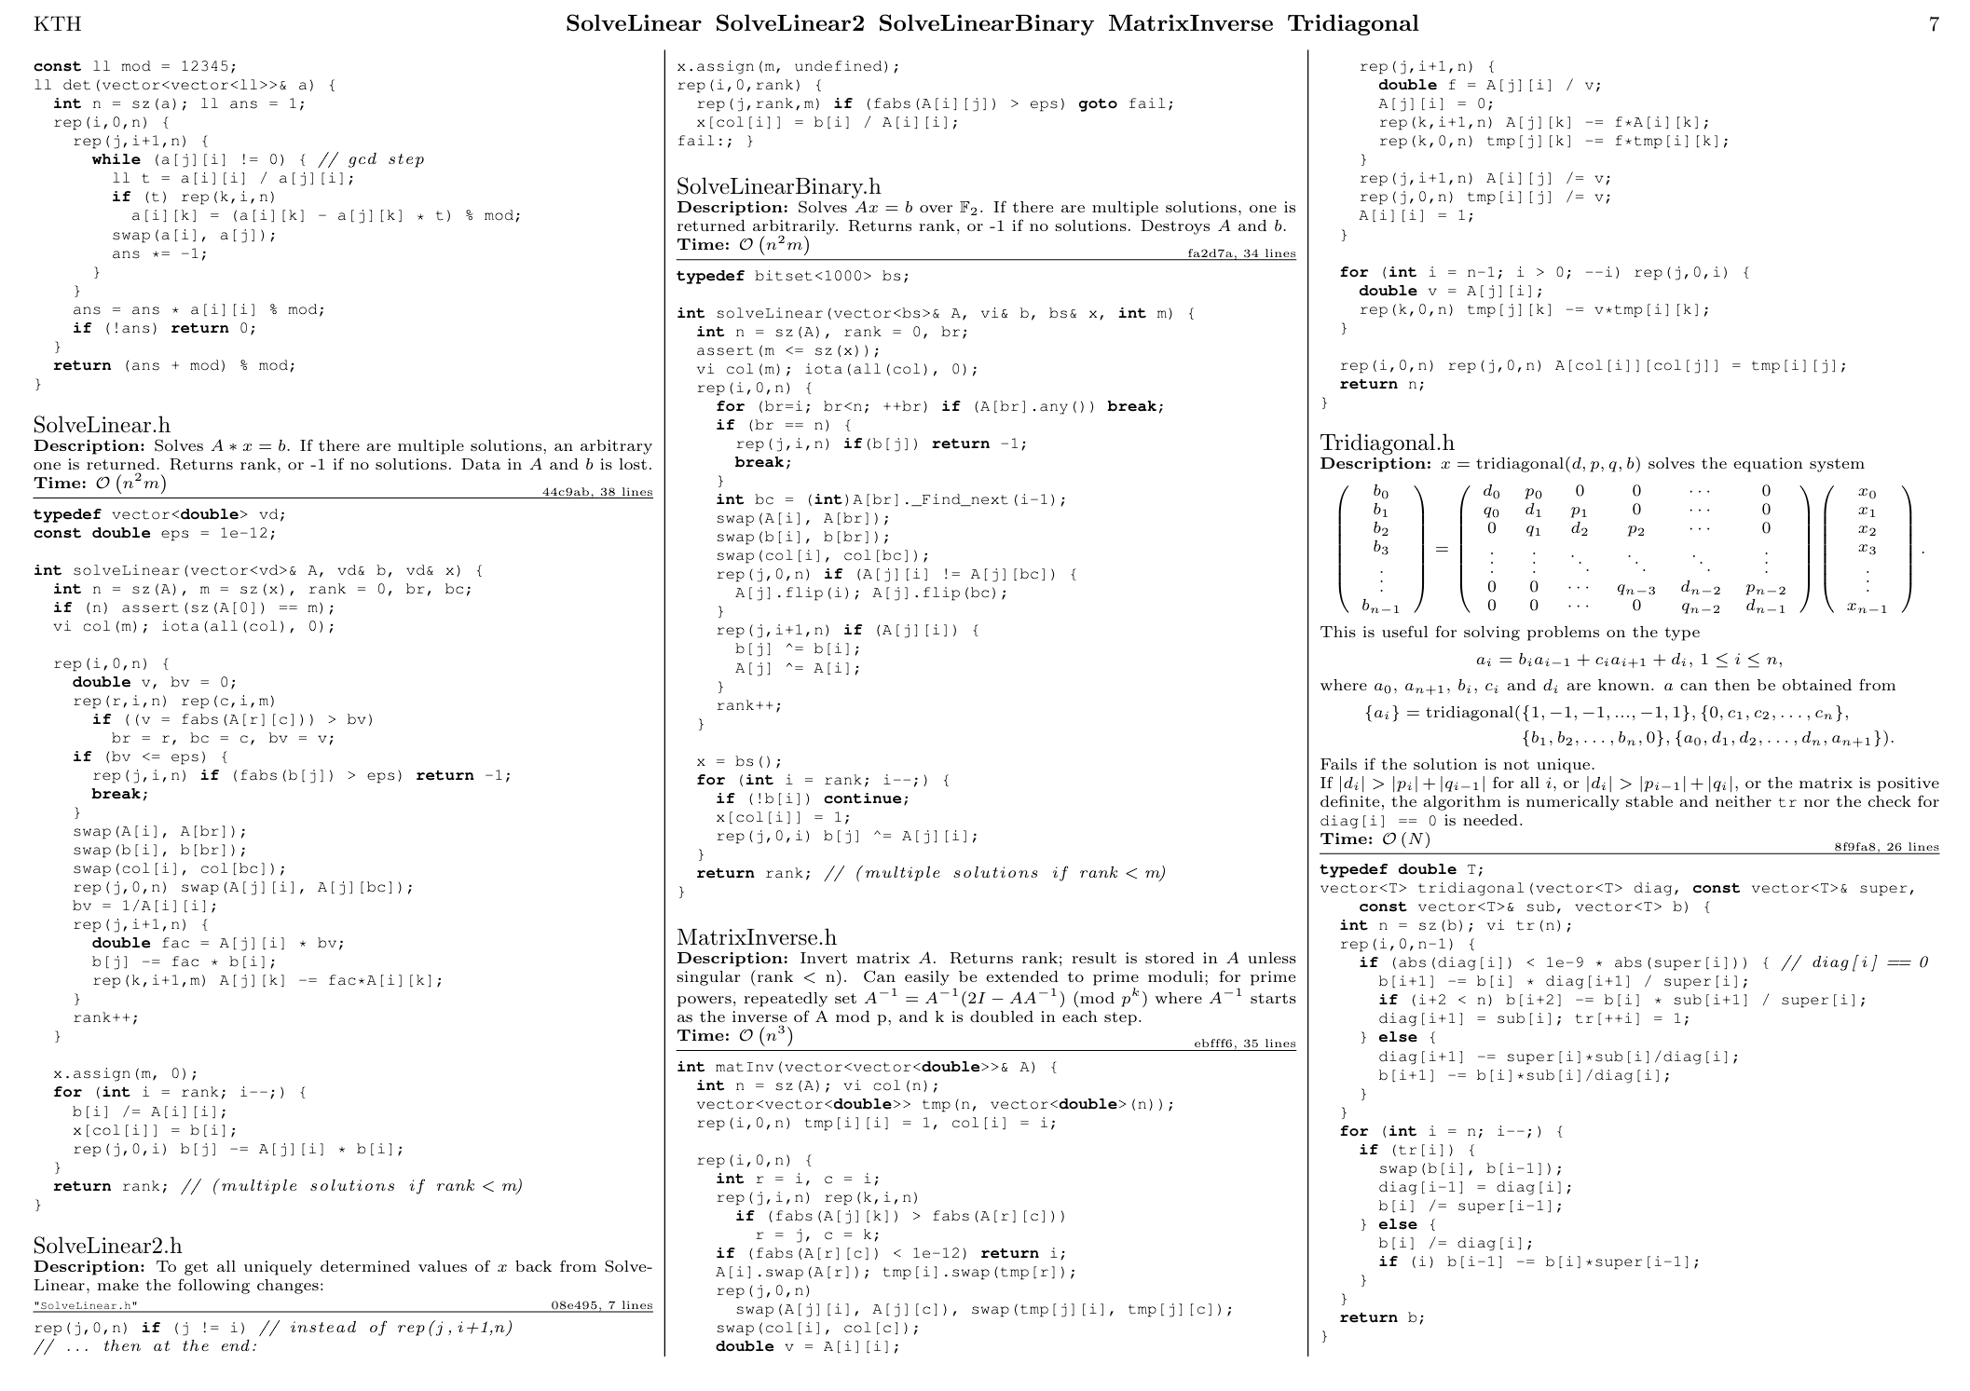

CU

7

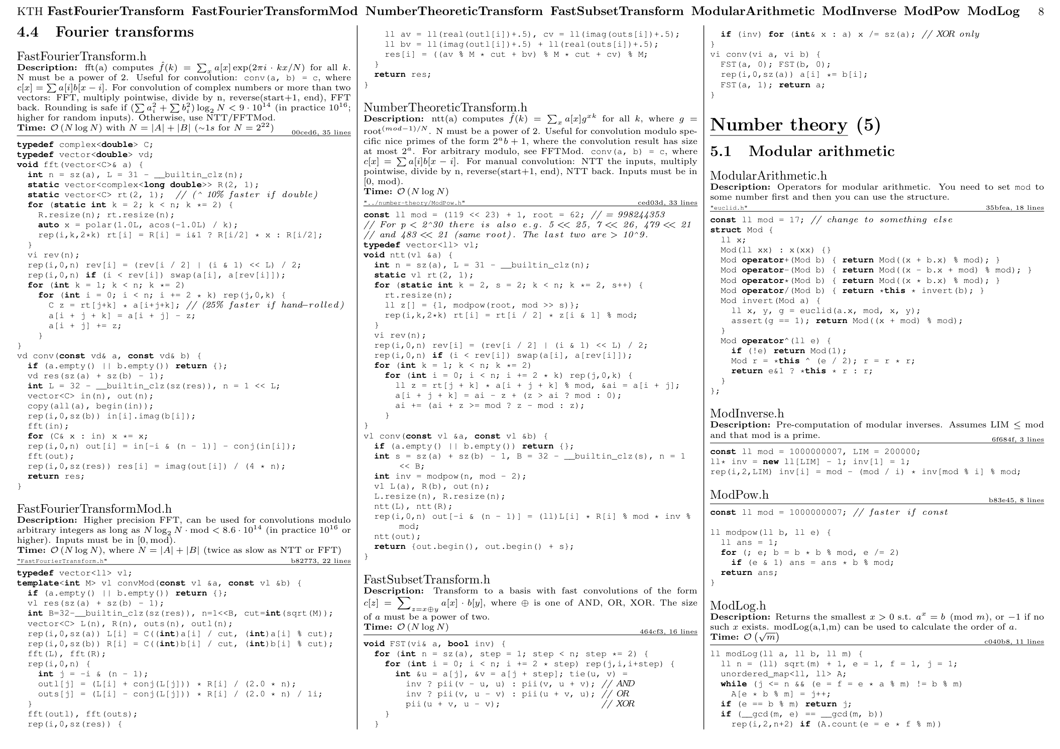

CU

8

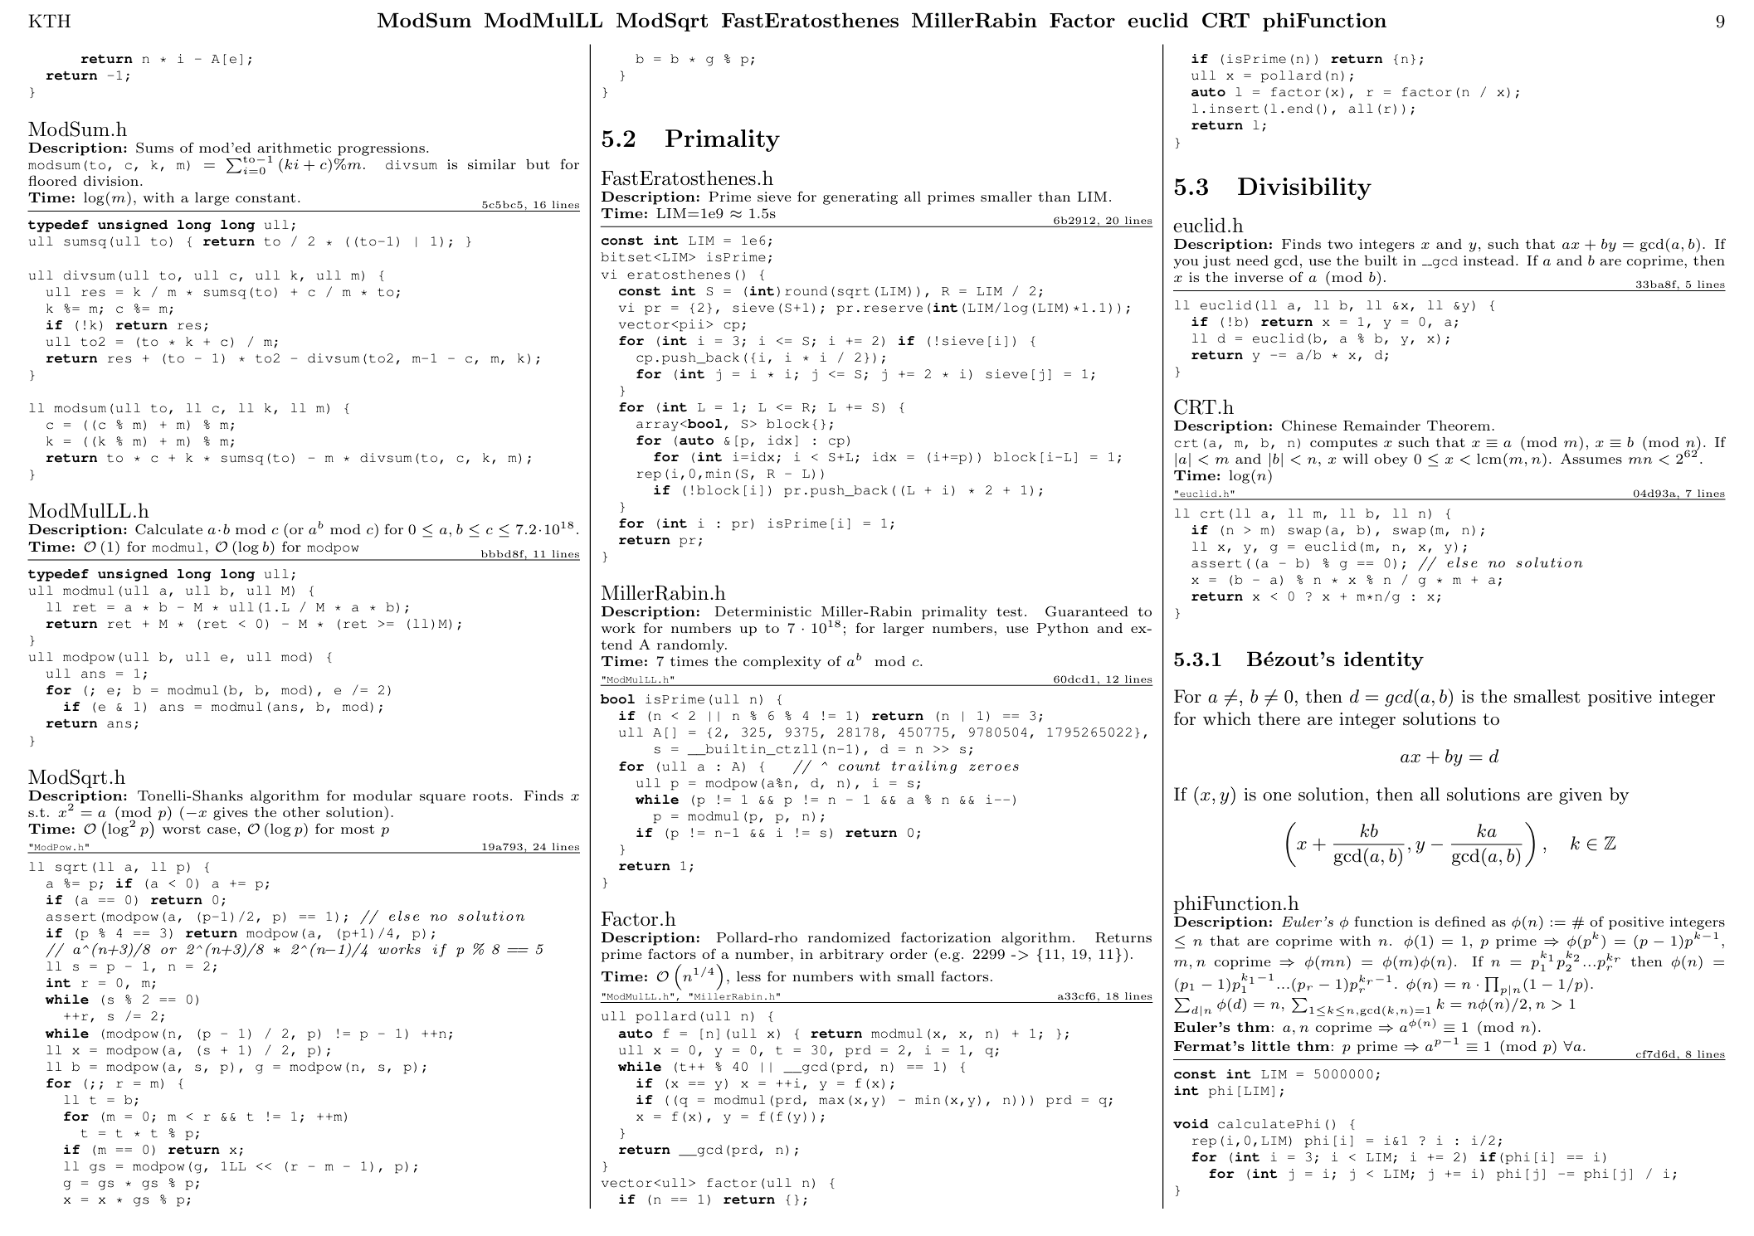

CU

9

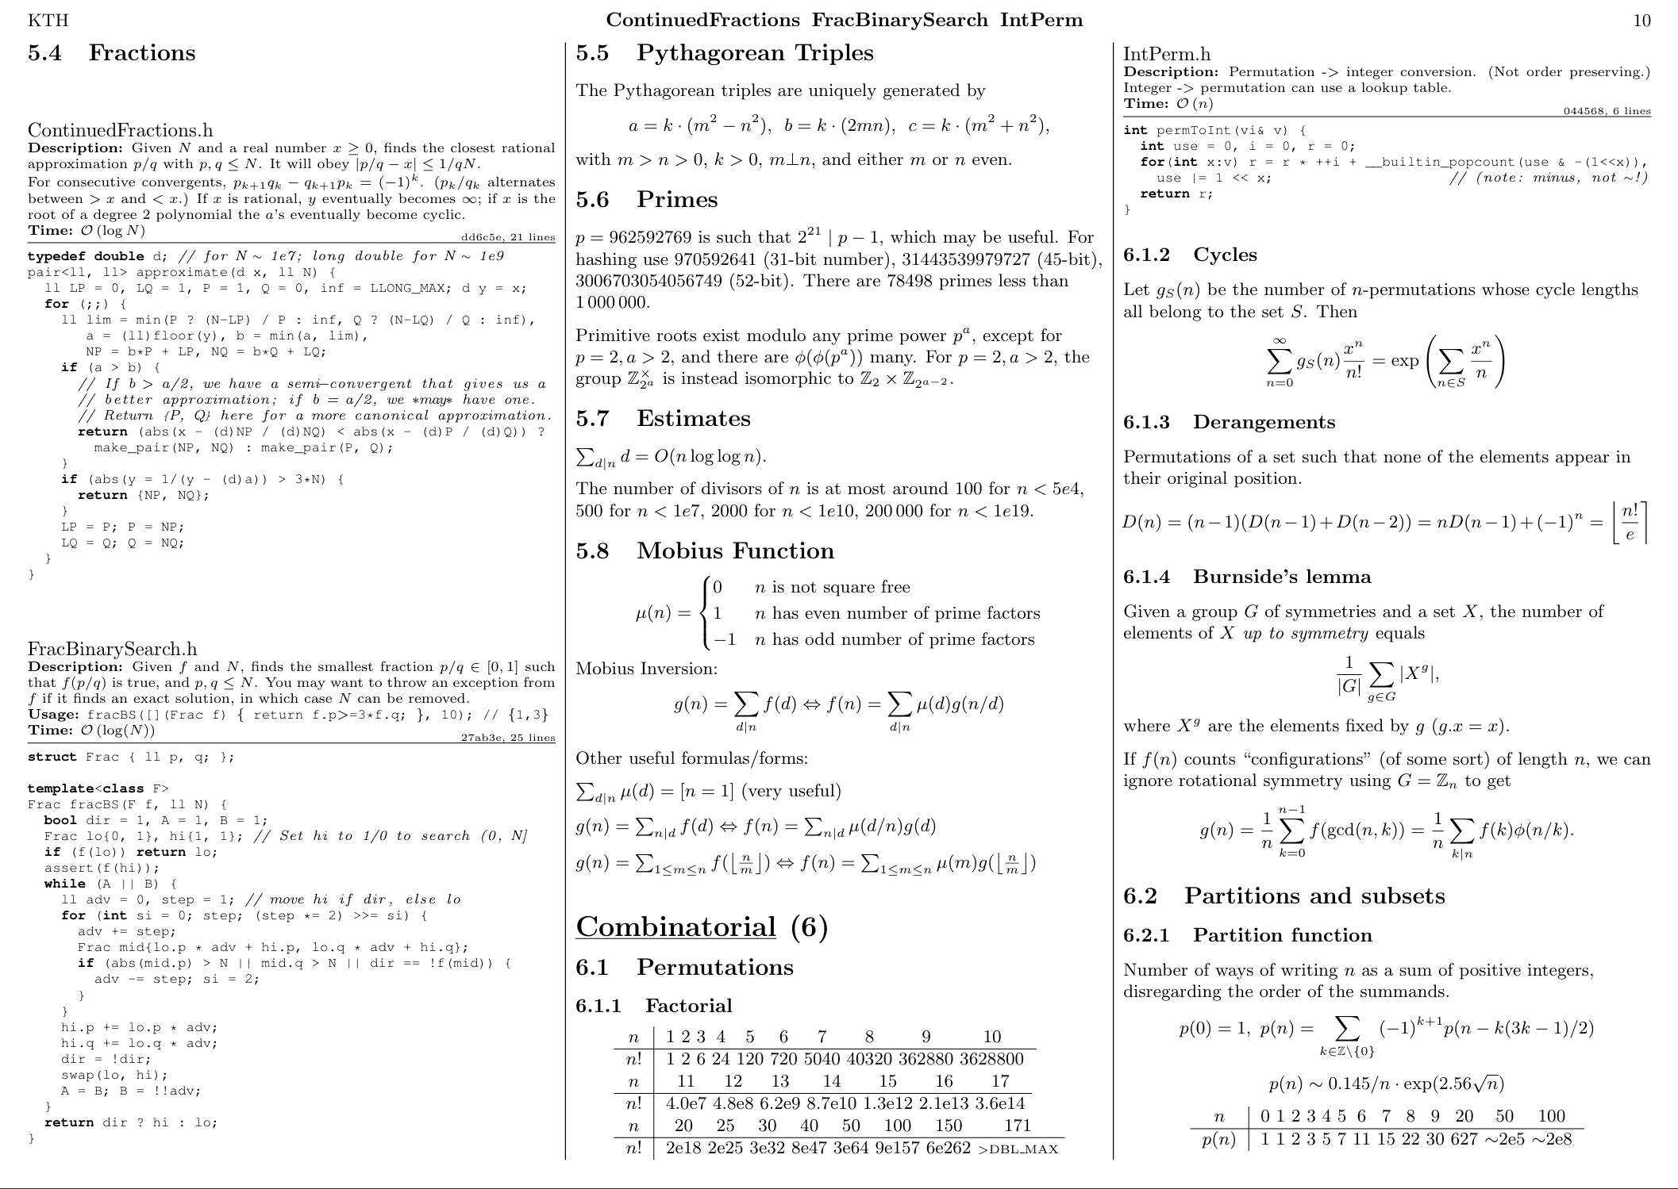

CU

10

CU

11

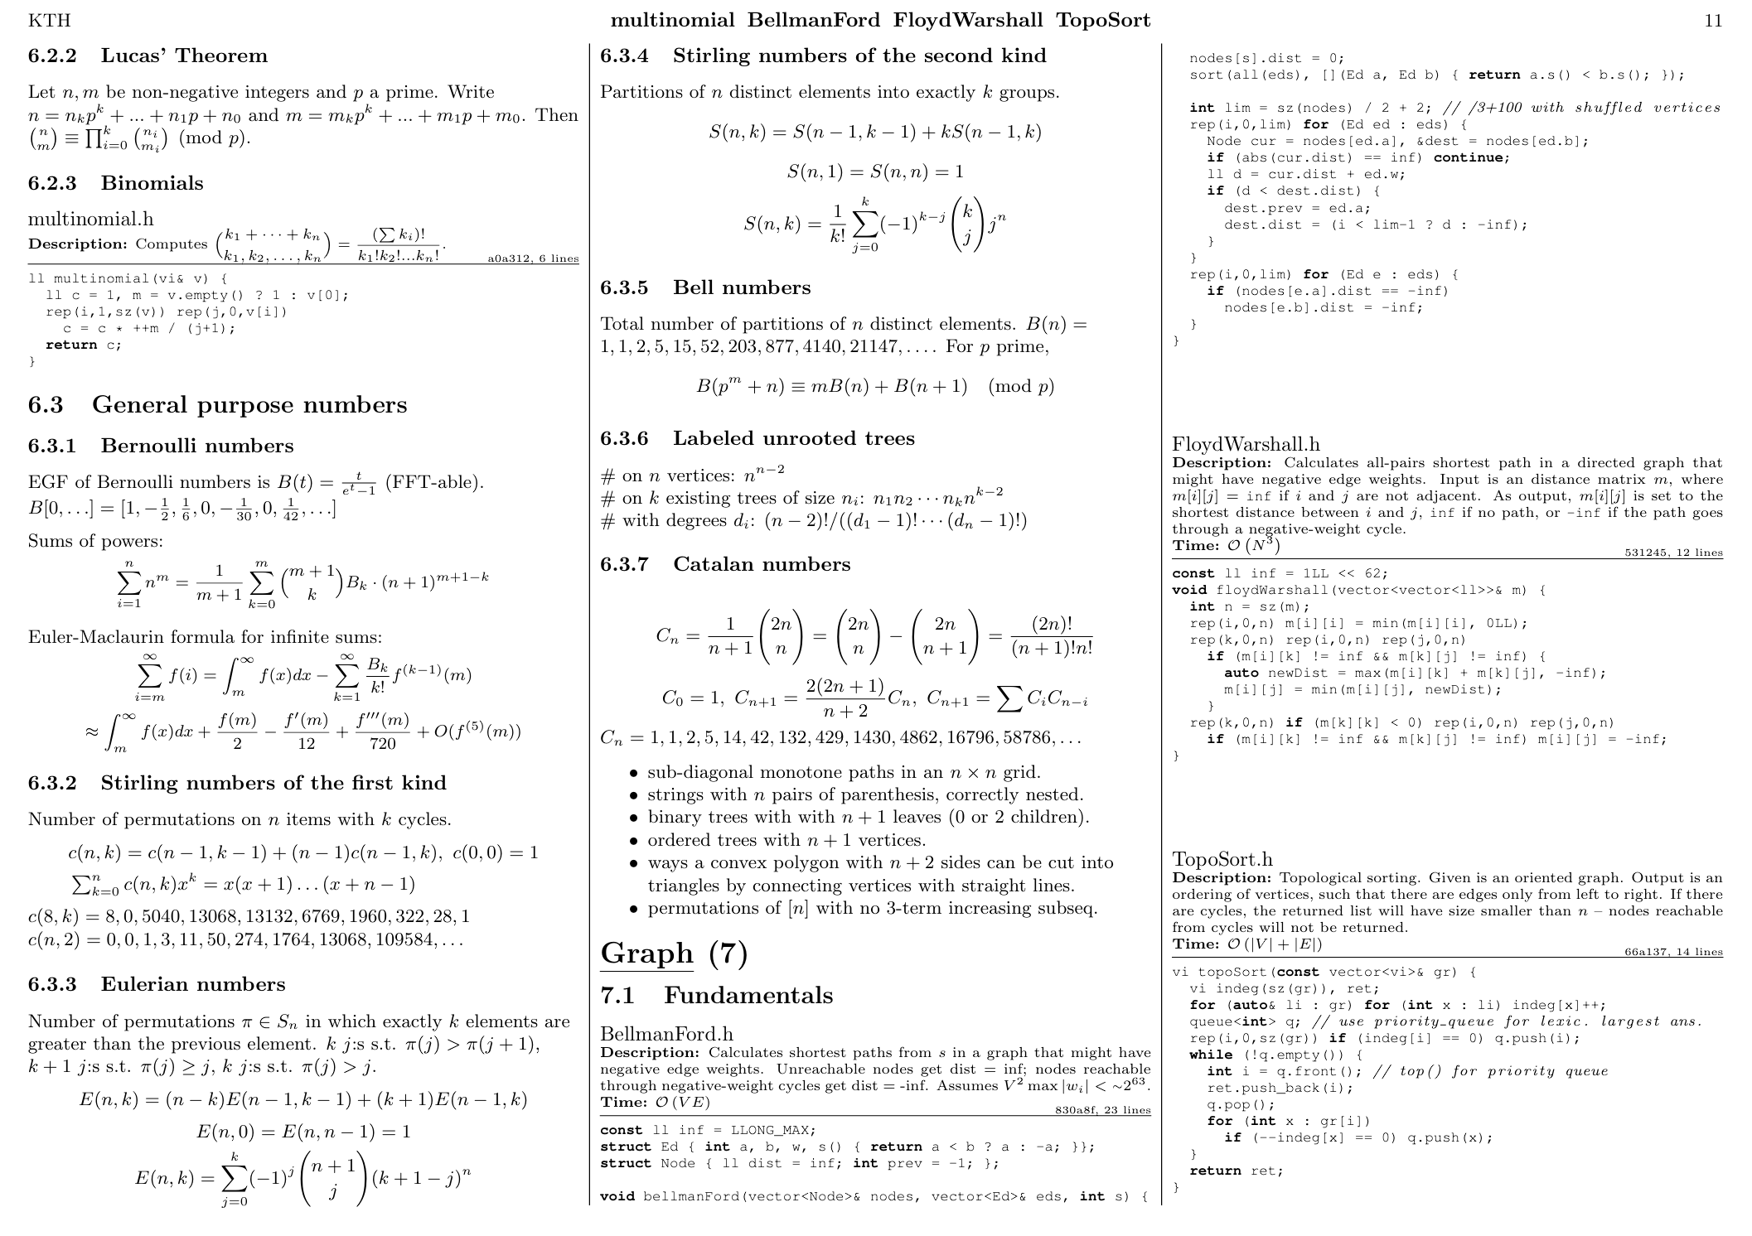

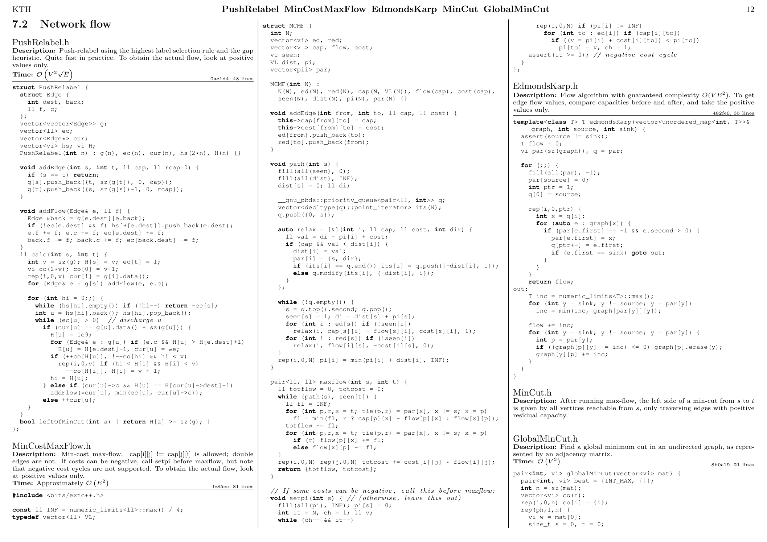

CU

12

CU

13

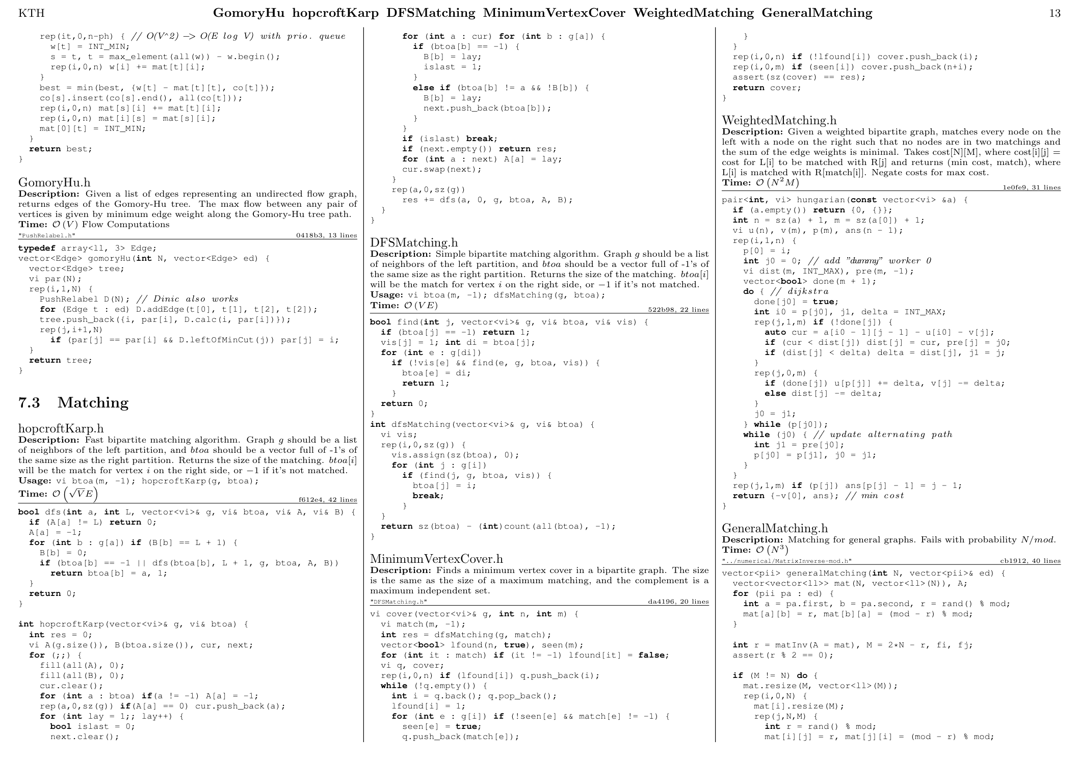

CU

14

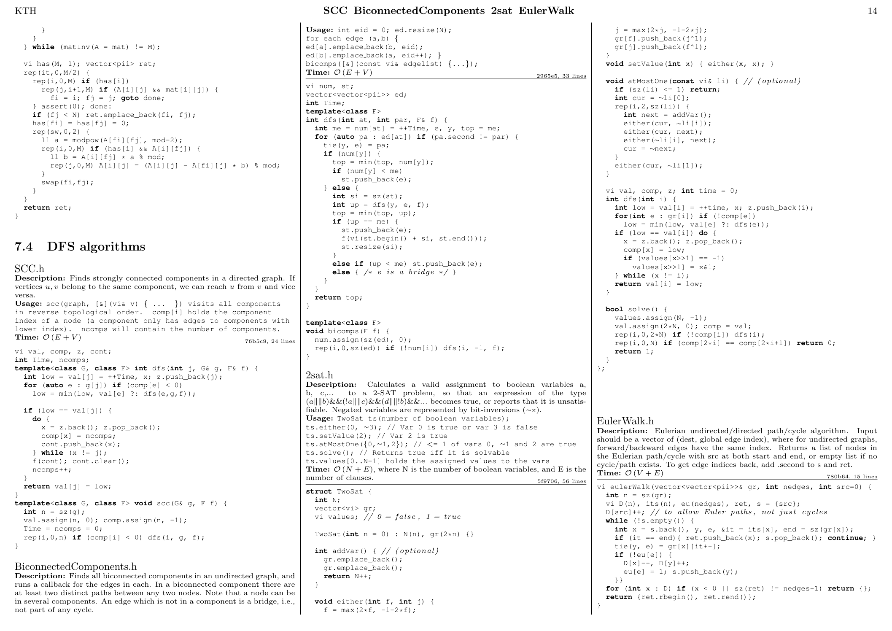

CU

15

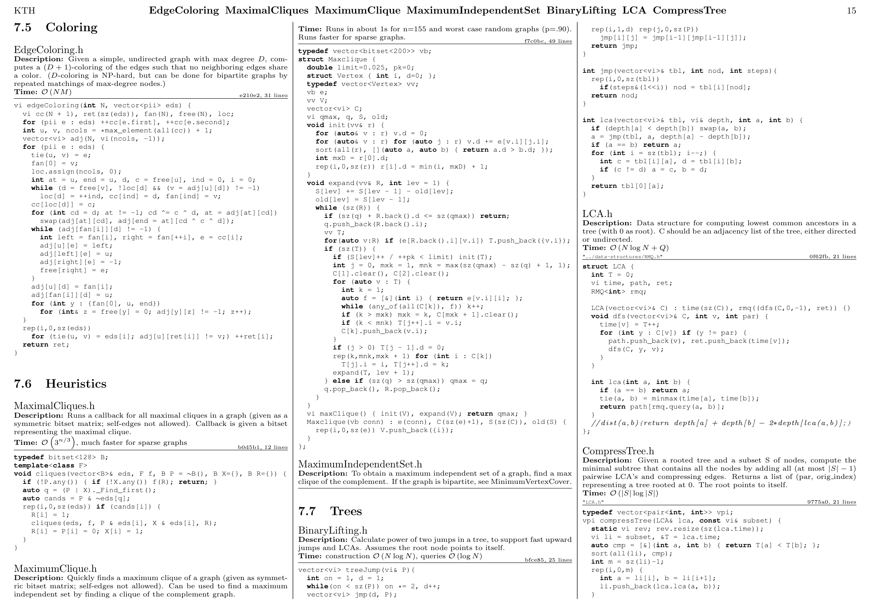

CU

16

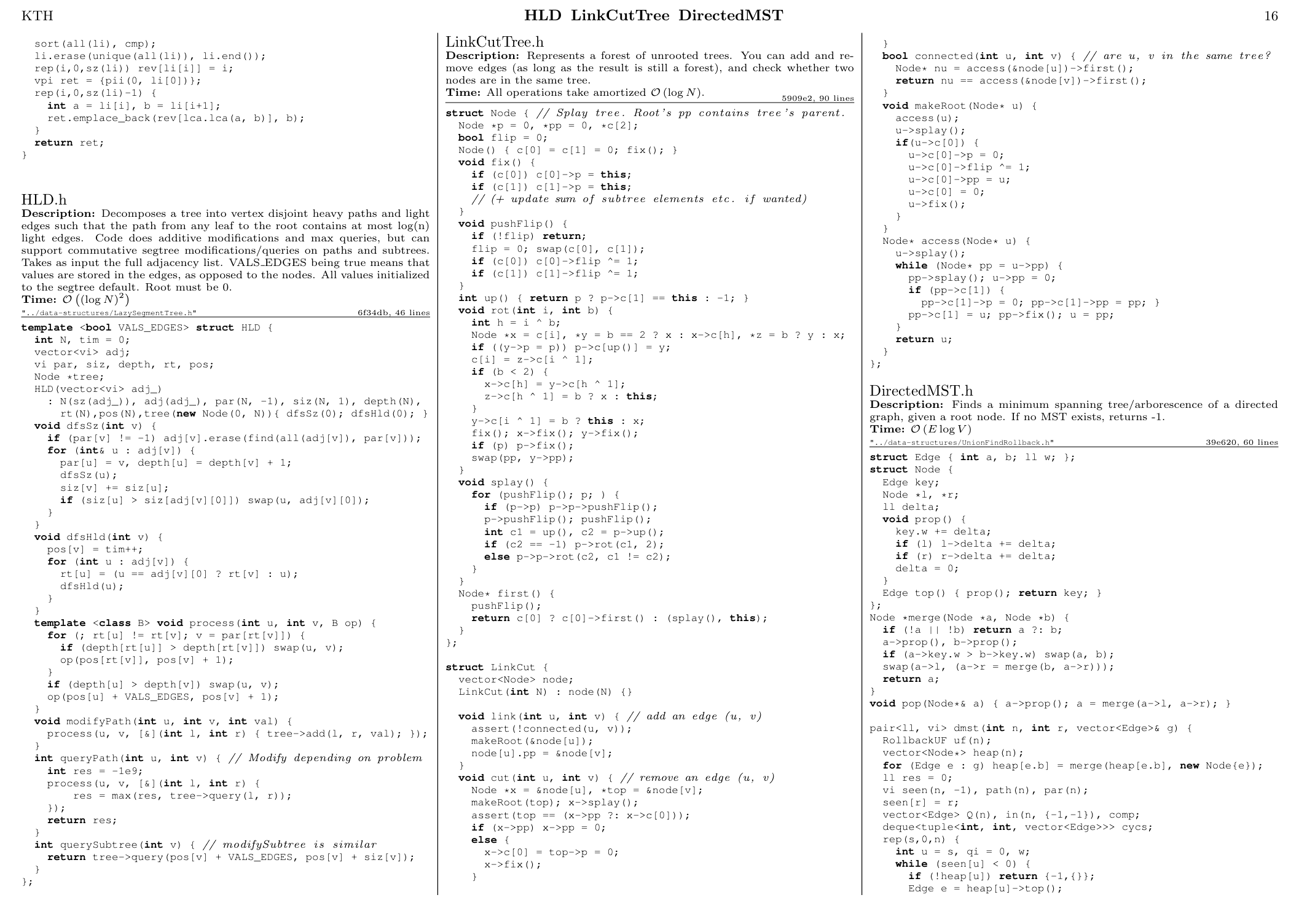

CU

17

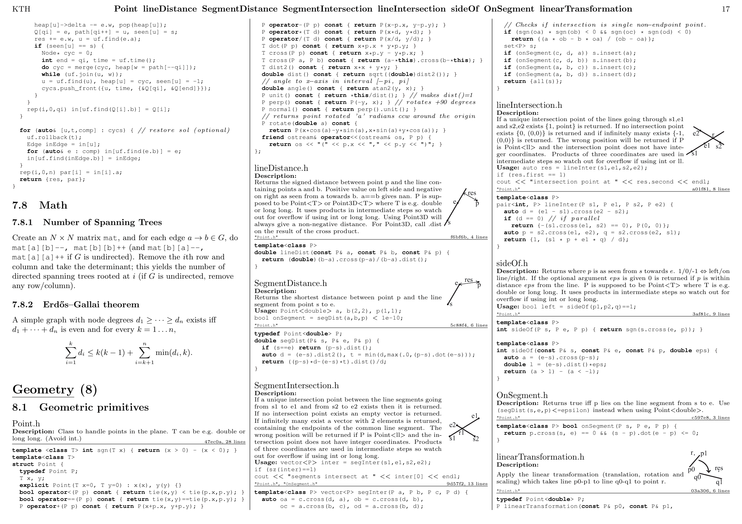

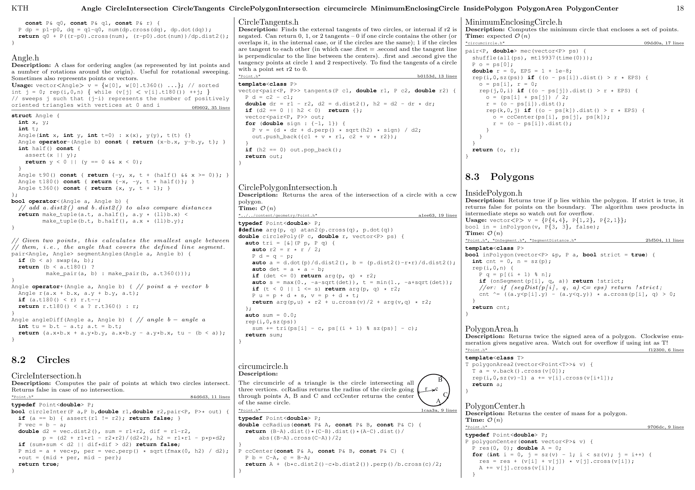

CU

18

CU

19

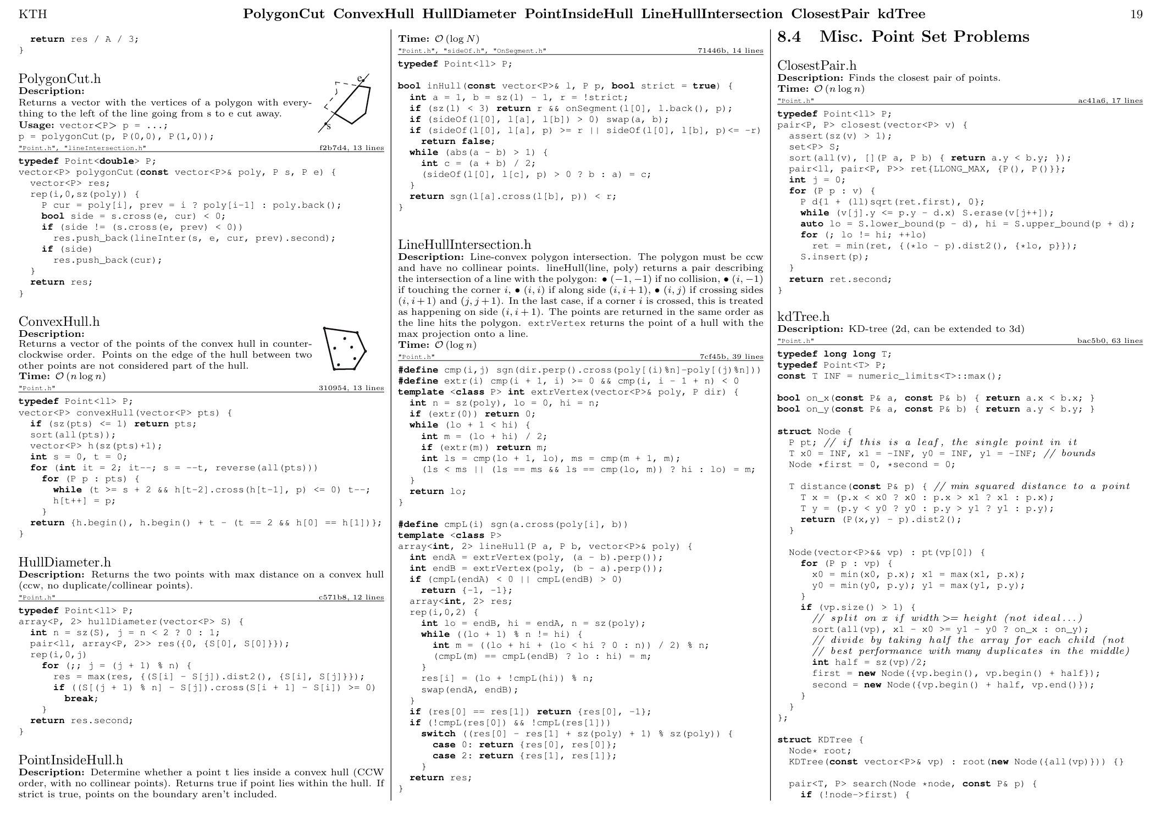

CU

20

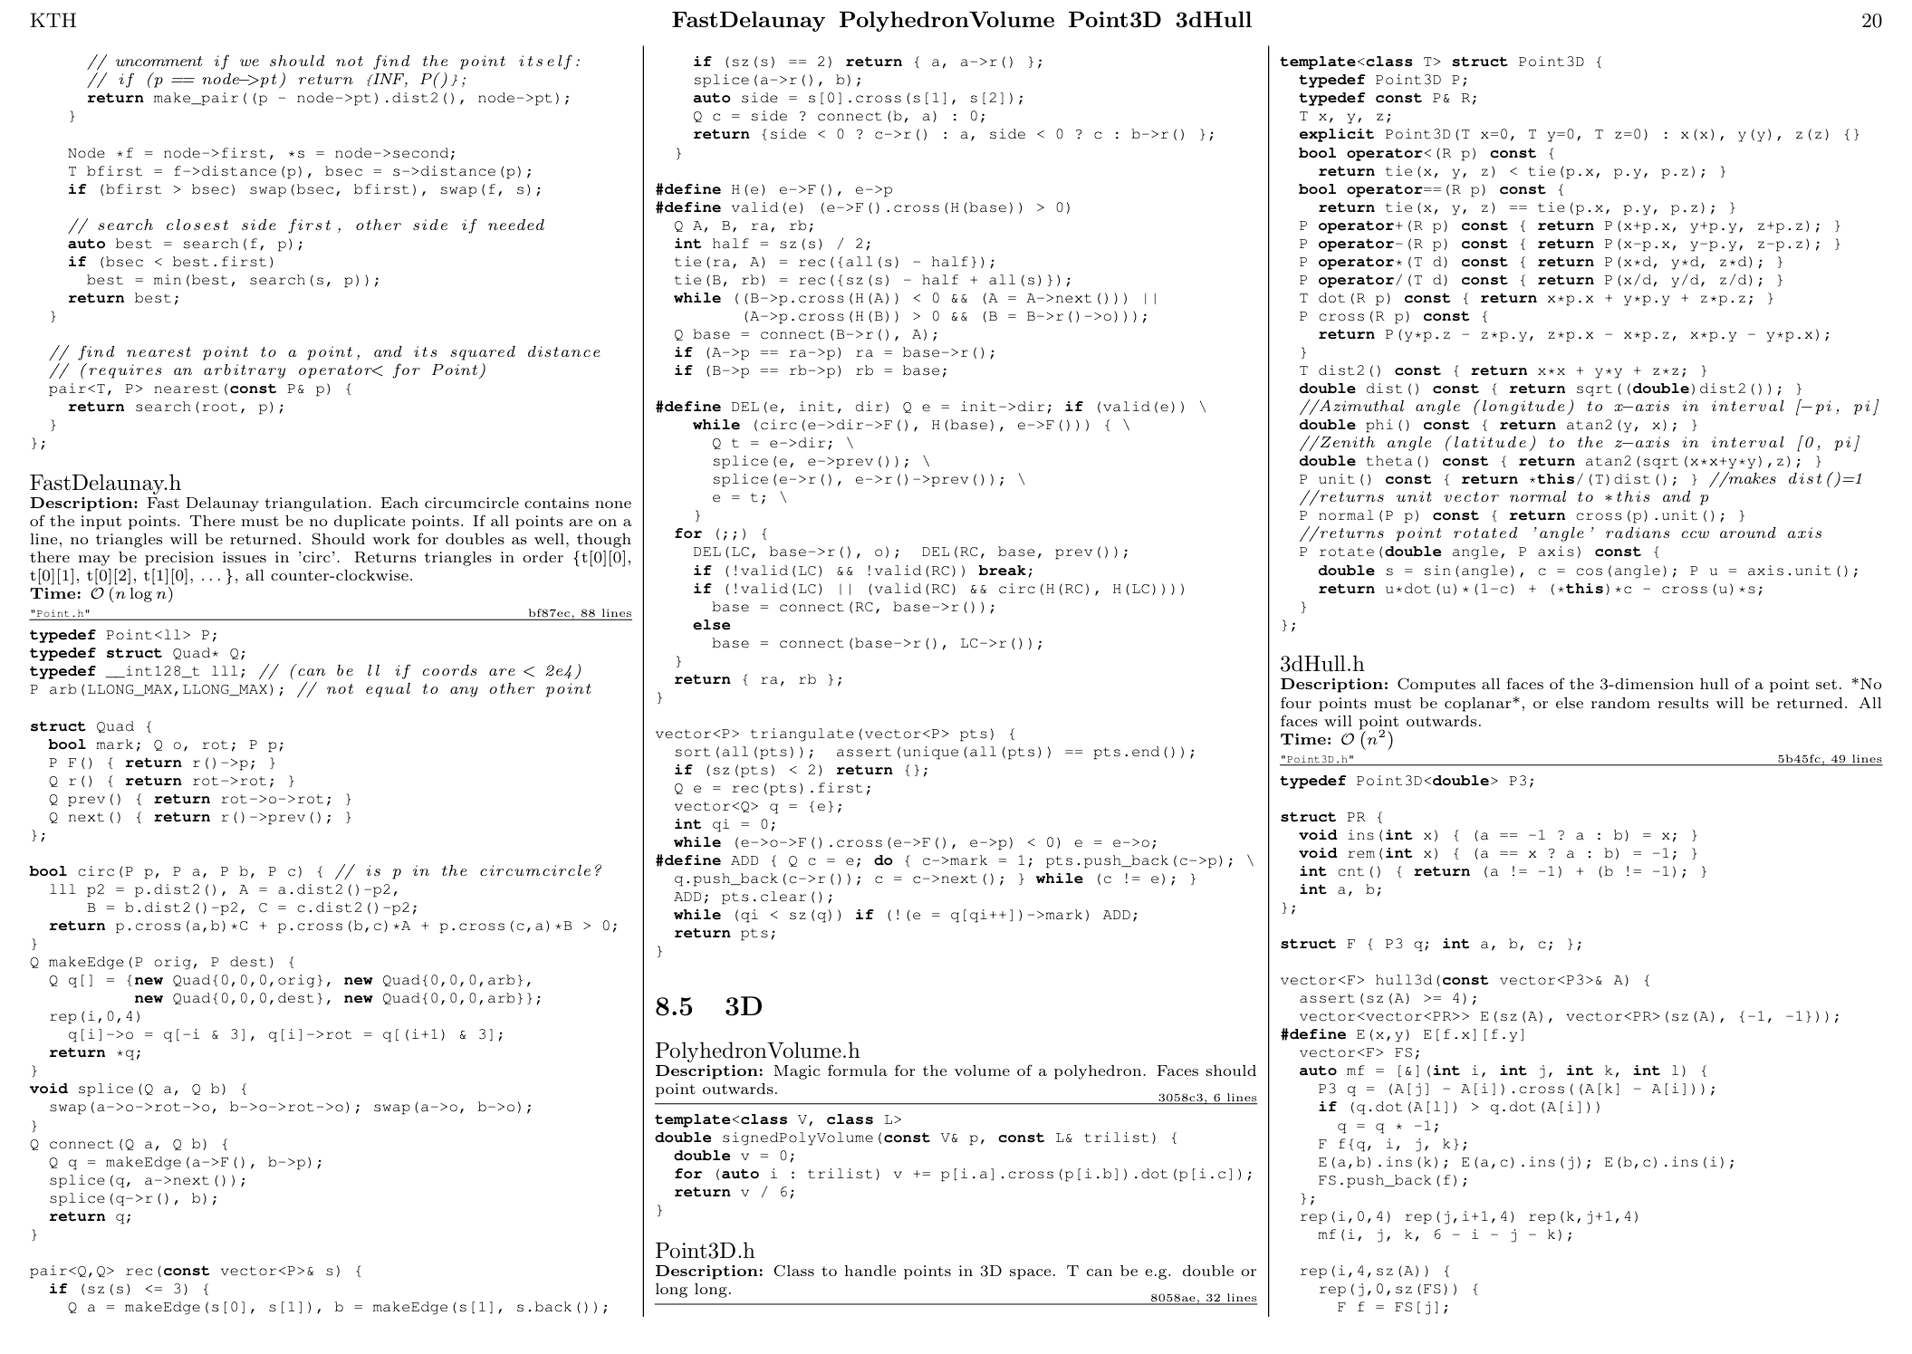

CU

21

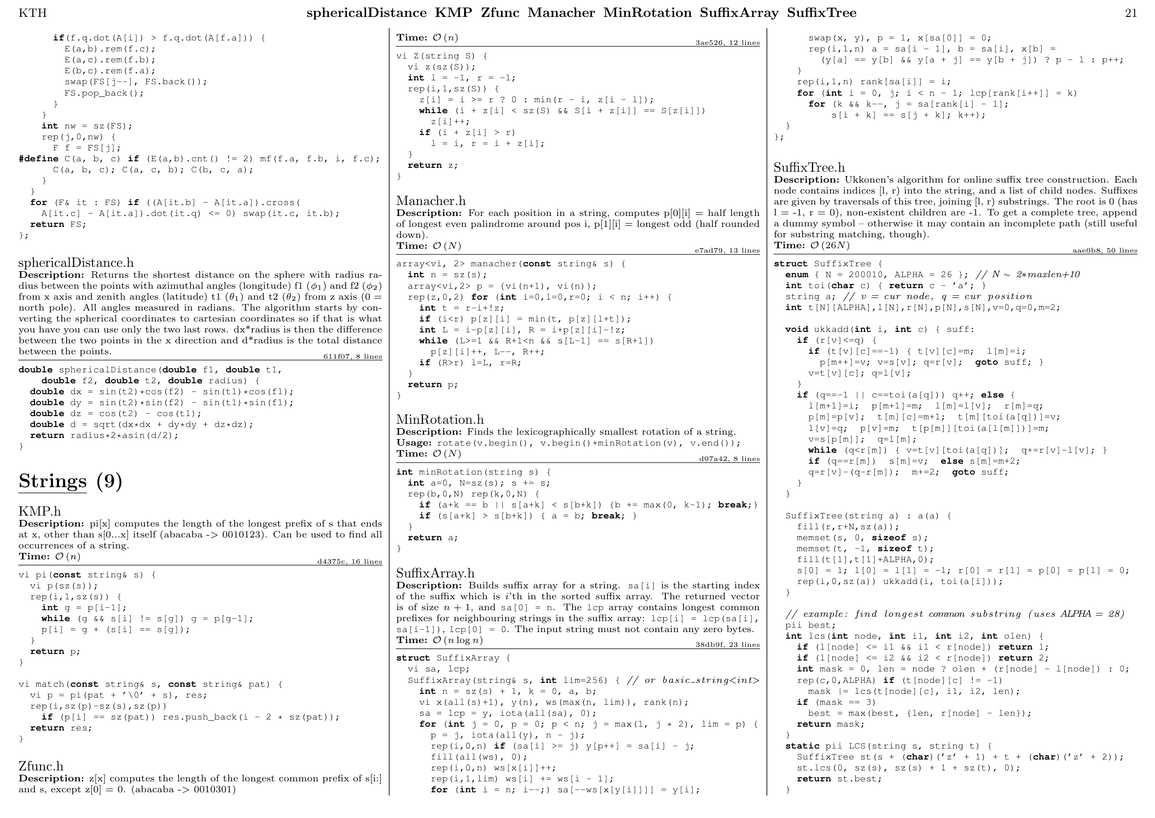

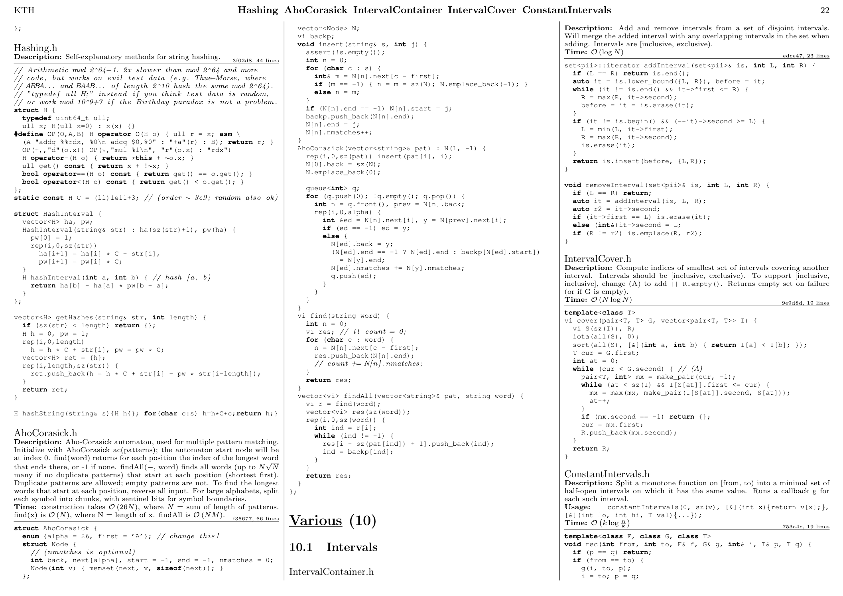

CU

22

CU

23

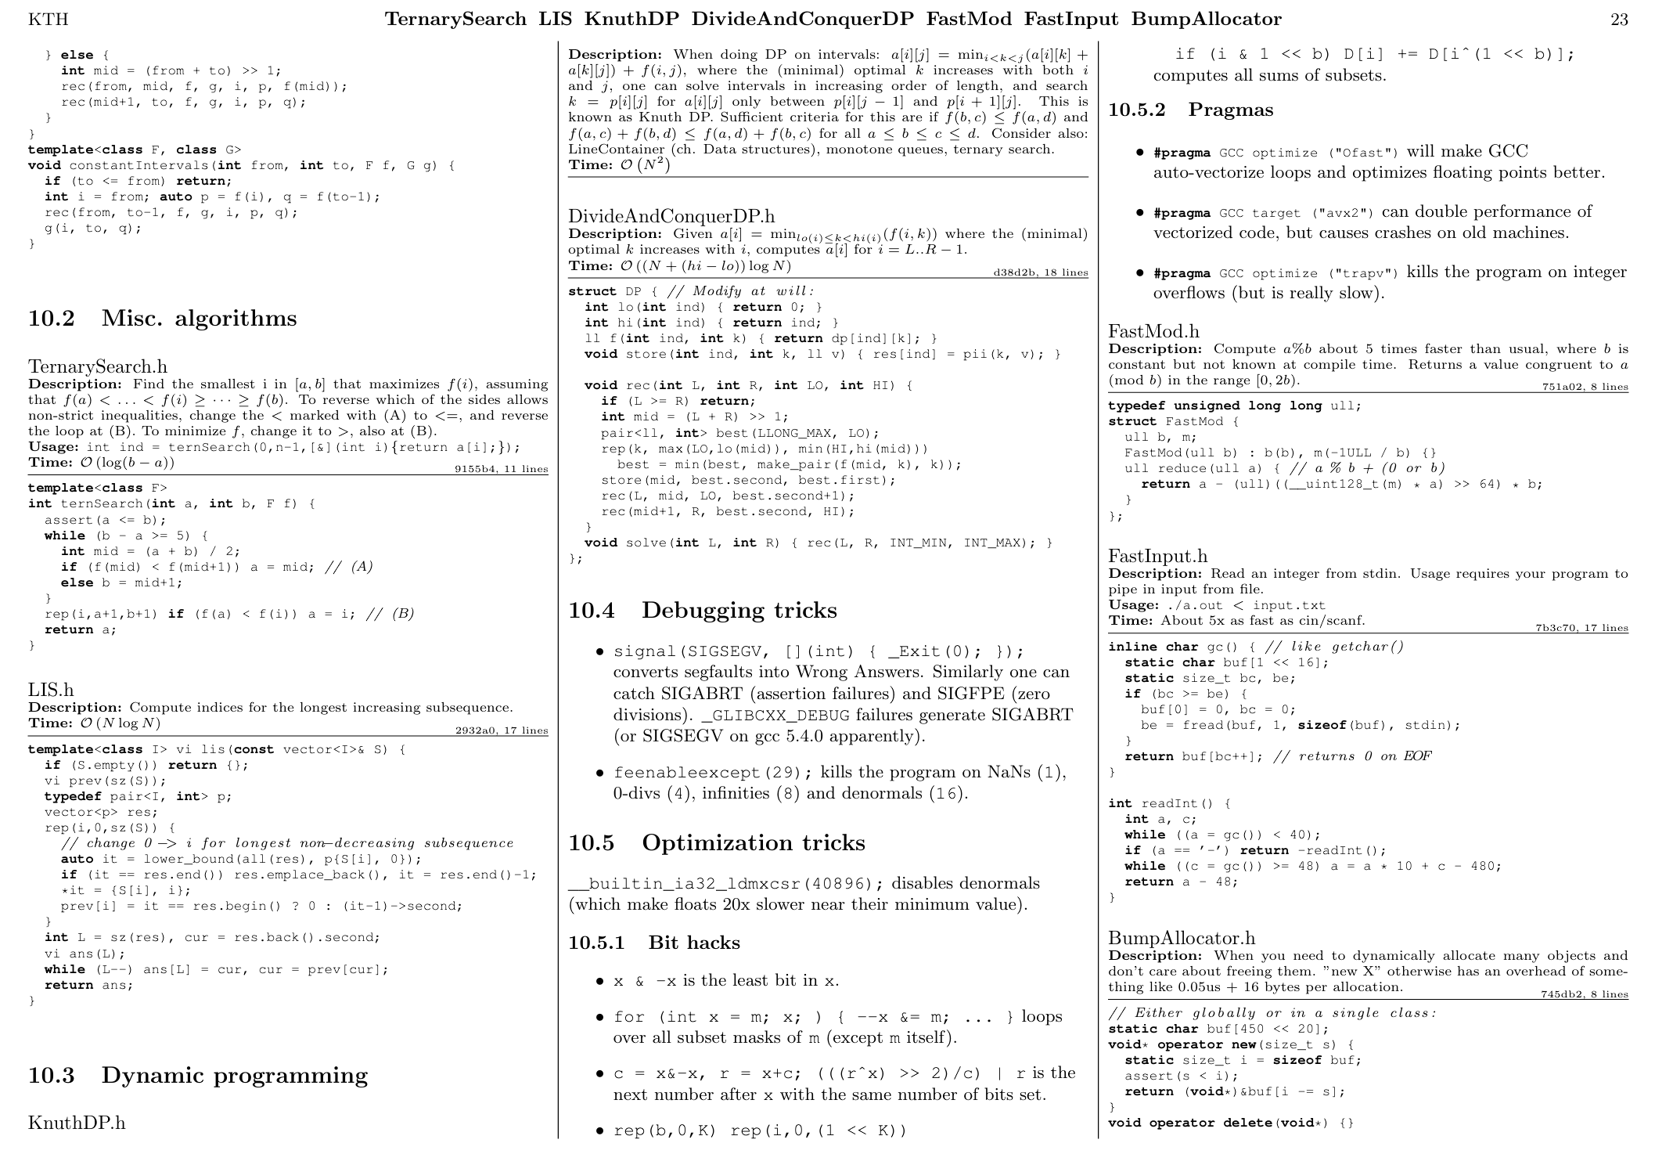

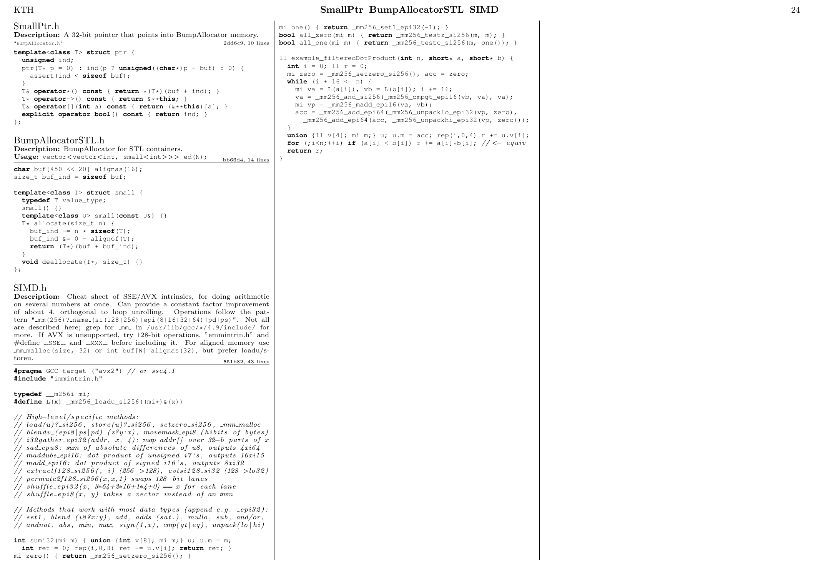

ll count_primes(ll n) {

vector<ll> v;

for (ll k = 1; k * k <= n; k++) {

v.push_back(n / k);

v.push_back(k);}

sort(v.begin(), v.end());

v.erase(std::unique(v.begin(), v.end()), v.end());

ll sq = sqrt(n);

auto geti = [&](ll x) {

if (x <= sq)

return (int)x - 1;

else

return (int)(v.size() - (n / x));

};

vector<ll> dp(v.size());

for (int i = 0; i < v.size(); i++) { dp[i] = v[i]; }

int a = 0;

for (ll p = 2; p * p <= n; p++) {

// this condition is true for primes

if (dp[geti(p)] != dp[geti(p - 1)]) {

a++;

for (int i = (int)v.size() - 1; i >= 0; --i) {

if (v[i] < p * p) { break; }

dp[i] -= dp[geti(v[i] / p)] - a;

}

}

}

return dp[geti(n)] - 1;

}

O(N^(3/4)/sqrt(log(N)))

Fermat prime test

A^n-1 mod n == 1?

n may prime

but n=561 will fail

High composite

360 : 24

840 : 32

2520 : 48

5040 : 60

83160 : 128

110880 : 144

720720 : 240

1081080 : 256

Prime count

10^3 : 168

10^4 : 1229

10^5 : 9592

10^6 : 78498

CU

24

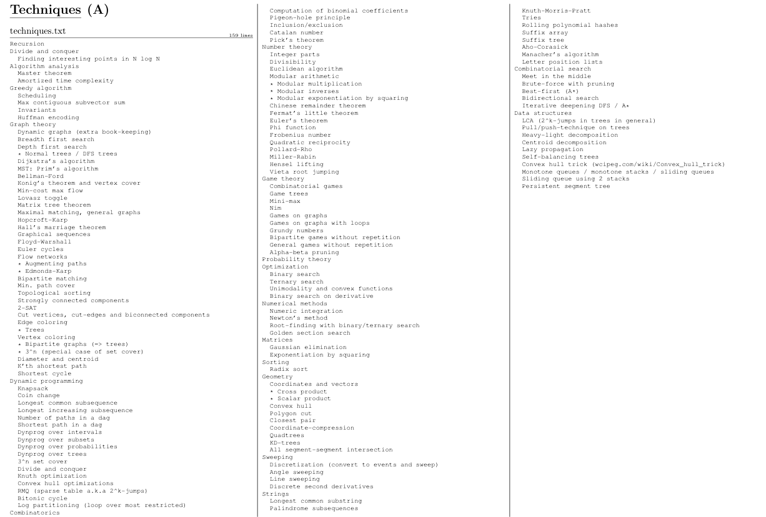

CU

**25**